Project Design Phase
Solution Architecture

Date | 1 October 2026
Team ID | SWTID-2026-5148
Project Name | Implement Client Script & UI Policy (Incident)
Maximum Marks | 4 Marks
Team: Mathangi S (Team Leader), Meena Varshini T P, Mirthika R, Muthu Priya U | Team Size: 4
Solution Architecture:
Solution architecture is a complex process – with many sub-processes – that bridges the gap between business problems and technology solutions. Its goals are to:
- Find the best tech solution to solve existing business problems.
- Describe the structure, characteristics, behavior, and other aspects of the software to project stakeholders.
- Define features, development phases, and solution requirements.
- Provide specifications according to which the solution is defined, managed, and delivered.

Solution Architecture Diagram:

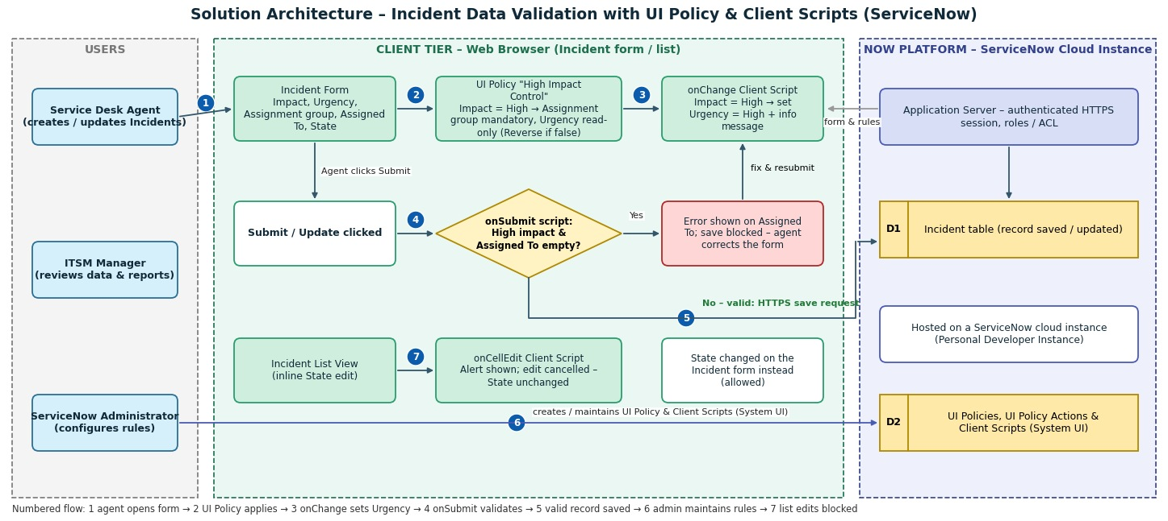
Figure 1: Architecture and data flow of the Incident Client Script & UI Policy solution
Reference: Project document – Implement Client Script & UI Policy (Incident)

Data flow and components:
1. The service desk agent opens the Incident form in the browser; the form and the rules (UI Policy and Client Scripts) are delivered by the ServiceNow application server.
2. When Impact is set to High, the UI Policy "High Impact Control" makes Assignment group mandatory and Urgency read-only; Reverse if false restores the fields otherwise.
3. The onChange Client Script sets Urgency to High and shows an information message.
4. On Submit/Update, the onSubmit Client Script checks Assigned To; if it is empty for a High-impact incident, an error is shown and the save is blocked.
5. If validation passes, the record is saved to the Incident table through the application server.
6. The administrator creates and maintains the UI Policy, UI Policy Actions and Client Scripts in System UI.
7. If a user edits State directly in the list view, the onCellEdit Client Script shows an alert and cancels the change; State is changed on the form instead.

